## CSS를 html 에 삽입하는 3가지 방법

|  |
| --- |
| <head> <link rel="stylesheet" type="text/css" href="mystyle.css"> </head> |
| <h1 style="color:blue;margin-left:30px;">This is a heading.</h1> |
| <head> <style> body {     background-color: linen; }  h1 {     color: maroon;     margin-left: 40px; }  </style> </head> |

CSS 문법

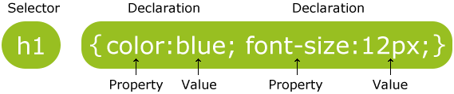

Selector는 엘리먼트 이름, id, class, 속성 등으로 엘리먼트를 찾는다.

CSS는 **selector, properties** 그리고 **@-rules** 요소를 갖고 있다.

|  |  |  |  |
| --- | --- | --- | --- |
| 1. Selectors | | | |
| u[niversal](https://www.developphp.com/lib/CSS/universal)  [type](https://www.developphp.com/lib/CSS/type)  [compound](https://www.developphp.com/lib/CSS/compound)  [class](https://www.developphp.com/lib/CSS/class)  [id](https://www.developphp.com/lib/CSS/id)  [not](https://www.developphp.com/lib/CSS/not)  [attribute](https://www.developphp.com/lib/CSS/attribute)  [descendant](https://www.developphp.com/lib/CSS/descendant)  [child](https://www.developphp.com/lib/CSS/child)  [adjacent sibling](https://www.developphp.com/lib/CSS/adjacent-sibling) | [general sibling](https://www.developphp.com/lib/CSS/general-sibling)  [first child](https://www.developphp.com/lib/CSS/first-child)  [last child](https://www.developphp.com/lib/CSS/last-child)  [only child](https://www.developphp.com/lib/CSS/only-child)  [first of type](https://www.developphp.com/lib/CSS/first-of-type)  [last of type](https://www.developphp.com/lib/CSS/last-of-type)  [only of type](https://www.developphp.com/lib/CSS/only-of-type)  [nth child](https://www.developphp.com/lib/CSS/nth-child)  [nth last child](https://www.developphp.com/lib/CSS/nth-last-child)  [nth of type](https://www.developphp.com/lib/CSS/nth-of-type) | [nth last of type](https://www.developphp.com/lib/CSS/nth-last-of-type)  [empty](https://www.developphp.com/lib/CSS/empty)  [root](https://www.developphp.com/lib/CSS/root)  [first line](https://www.developphp.com/lib/CSS/first-line)  [first letter](https://www.developphp.com/lib/CSS/first-letter)  [before](https://www.developphp.com/lib/CSS/before)  [after](https://www.developphp.com/lib/CSS/after)  [link](https://www.developphp.com/lib/CSS/link)  [visited](https://www.developphp.com/lib/CSS/visited)  [hover](https://www.developphp.com/lib/CSS/hover) | [active](https://www.developphp.com/lib/CSS/active)  [focus](https://www.developphp.com/lib/CSS/focus)  [target](https://www.developphp.com/lib/CSS/target)  [enabled](https://www.developphp.com/lib/CSS/enabled)  [disabled](https://www.developphp.com/lib/CSS/disabled)  [checked](https://www.developphp.com/lib/CSS/checked)  [lang](https://www.developphp.com/lib/CSS/lang) |

|  |  |  |
| --- | --- | --- |
| 2. Properties | | |
| [gn-content](https://www.developphp.com/lib/CSS/align-content)  [align-items](https://www.developphp.com/lib/CSS/align-items)  [align-self](https://www.developphp.com/lib/CSS/align-self)  [alignment-adjust](https://www.developphp.com/lib/CSS/alignment-adjust)  [alignment-baseline](https://www.developphp.com/lib/CSS/alignment-baseline)  [all](https://www.developphp.com/lib/CSS/all)  [animation](https://www.developphp.com/lib/CSS/animation)  [animation-delay](https://www.developphp.com/lib/CSS/animation-delay)  [animation-direction](https://www.developphp.com/lib/CSS/animation-direction)  [animation-duration](https://www.developphp.com/lib/CSS/animation-duration)  [animation-fill-mode](https://www.developphp.com/lib/CSS/animation-fill-mode)  [animation-iteration-count](https://www.developphp.com/lib/CSS/animation-iteration-count)  [animation-name](https://www.developphp.com/lib/CSS/animation-name)  [animation-play-state](https://www.developphp.com/lib/CSS/animation-play-state)  [animation-timing-function](https://www.developphp.com/lib/CSS/animation-timing-function)  [azimuth](https://www.developphp.com/lib/CSS/azimuth)  [backface-visibility](https://www.developphp.com/lib/CSS/backface-visibility)  [background](https://www.developphp.com/lib/CSS/background)  [background-attachment](https://www.developphp.com/lib/CSS/background-attachment)  [background-blend-mode](https://www.developphp.com/lib/CSS/background-blend-mode)  [background-clip](https://www.developphp.com/lib/CSS/background-clip)  [background-color](https://www.developphp.com/lib/CSS/background-color)  [background-image](https://www.developphp.com/lib/CSS/background-image)  [background-origin](https://www.developphp.com/lib/CSS/background-origin)  [background-position](https://www.developphp.com/lib/CSS/background-position)  [background-repeat](https://www.developphp.com/lib/CSS/background-repeat)  [background-size](https://www.developphp.com/lib/CSS/background-size)  [baseline-shift](https://www.developphp.com/lib/CSS/baseline-shift)  [bookmark-label](https://www.developphp.com/lib/CSS/bookmark-label)  [bookmark-level](https://www.developphp.com/lib/CSS/bookmark-level)  [bookmark-state](https://www.developphp.com/lib/CSS/bookmark-state)  [border](https://www.developphp.com/lib/CSS/border)  [border-bottom](https://www.developphp.com/lib/CSS/border-bottom)  [border-bottom-color](https://www.developphp.com/lib/CSS/border-bottom-color)  [border-bottom-left-radius](https://www.developphp.com/lib/CSS/border-bottom-left-radius)  [border-bottom-right-radius](https://www.developphp.com/lib/CSS/border-bottom-right-radius)  [border-bottom-style](https://www.developphp.com/lib/CSS/border-bottom-style)  [border-bottom-width](https://www.developphp.com/lib/CSS/border-bottom-width)  [border-collapse](https://www.developphp.com/lib/CSS/border-collapse)  [border-color](https://www.developphp.com/lib/CSS/border-color)  [border-image](https://www.developphp.com/lib/CSS/border-image)  [border-image-outset](https://www.developphp.com/lib/CSS/border-image-outset)  [font](https://www.developphp.com/lib/CSS/font)  [font-family](https://www.developphp.com/lib/CSS/font-family)  [font-feature-settings](https://www.developphp.com/lib/CSS/font-feature-settings)  [font-kerning](https://www.developphp.com/lib/CSS/font-kerning)  [font-language-override](https://www.developphp.com/lib/CSS/font-language-override)  [font-size](https://www.developphp.com/lib/CSS/font-size)  [font-size-adjust](https://www.developphp.com/lib/CSS/font-size-adjust)  [font-stretch](https://www.developphp.com/lib/CSS/font-stretch)  [font-style](https://www.developphp.com/lib/CSS/font-style)  [font-synthesis](https://www.developphp.com/lib/CSS/font-synthesis)  [font-variant](https://www.developphp.com/lib/CSS/font-variant)  [font-variant-alternates](https://www.developphp.com/lib/CSS/font-variant-alternates)  [font-variant-caps](https://www.developphp.com/lib/CSS/font-variant-caps)  [font-variant-east-asian](https://www.developphp.com/lib/CSS/font-variant-east-asian)  [font-variant-ligatures](https://www.developphp.com/lib/CSS/font-variant-ligatures)  [font-variant-numeric](https://www.developphp.com/lib/CSS/font-variant-numeric)  [font-variant-position](https://www.developphp.com/lib/CSS/font-variant-position)  [font-weight](https://www.developphp.com/lib/CSS/font-weight)  [footnote-display](https://www.developphp.com/lib/CSS/footnote-display)  [footnote-policy](https://www.developphp.com/lib/CSS/footnote-policy)  [grid](https://www.developphp.com/lib/CSS/grid)  [grid-area](https://www.developphp.com/lib/CSS/grid-area)  [grid-auto-columns](https://www.developphp.com/lib/CSS/grid-auto-columns)  [grid-auto-flow](https://www.developphp.com/lib/CSS/grid-auto-flow)  [grid-auto-rows](https://www.developphp.com/lib/CSS/grid-auto-rows)  [grid-column](https://www.developphp.com/lib/CSS/grid-column)  [grid-column-end](https://www.developphp.com/lib/CSS/grid-column-end)  [grid-column-start](https://www.developphp.com/lib/CSS/grid-column-start)  [grid-row](https://www.developphp.com/lib/CSS/grid-row)  [grid-row-end](https://www.developphp.com/lib/CSS/grid-row-end)  [grid-row-start](https://www.developphp.com/lib/CSS/grid-row-start)  [grid-template](https://www.developphp.com/lib/CSS/grid-template)  [grid-template-areas](https://www.developphp.com/lib/CSS/grid-template-areas)  [grid-template-columns](https://www.developphp.com/lib/CSS/grid-template-columns)  [grid-template-rows](https://www.developphp.com/lib/CSS/grid-template-rows)  [hanging-punctuation](https://www.developphp.com/lib/CSS/hanging-punctuation)  [height](https://www.developphp.com/lib/CSS/height)  [hyphens](https://www.developphp.com/lib/CSS/hyphens)  [image-orientation](https://www.developphp.com/lib/CSS/image-orientation)  [image-resolution](https://www.developphp.com/lib/CSS/image-resolution)  [initial-letter](https://www.developphp.com/lib/CSS/initial-letter)  [initial-letter-align](https://www.developphp.com/lib/CSS/initial-letter-align)  [inline-box-align](https://www.developphp.com/lib/CSS/inline-box-align)  [page-policy](https://www.developphp.com/lib/CSS/page-policy)  [pause](https://www.developphp.com/lib/CSS/pause)  [pause-after](https://www.developphp.com/lib/CSS/pause-after)  [pause-before](https://www.developphp.com/lib/CSS/pause-before)  [perspective](https://www.developphp.com/lib/CSS/perspective)  [perspective-origin](https://www.developphp.com/lib/CSS/perspective-origin)  [pitch](https://www.developphp.com/lib/CSS/pitch)  [pitch-range](https://www.developphp.com/lib/CSS/pitch-range)  [play-during](https://www.developphp.com/lib/CSS/play-during)  [position](https://www.developphp.com/lib/CSS/position)  [presentation-level](https://www.developphp.com/lib/CSS/presentation-level)  [quotes](https://www.developphp.com/lib/CSS/quotes)  [region-fragment](https://www.developphp.com/lib/CSS/region-fragment)  [resize](https://www.developphp.com/lib/CSS/resize)  [resolution](https://www.developphp.com/lib/CSS/resolution)  [rest](https://www.developphp.com/lib/CSS/rest)  [rest-after](https://www.developphp.com/lib/CSS/rest-after)  [rest-before](https://www.developphp.com/lib/CSS/rest-before)  [richness](https://www.developphp.com/lib/CSS/richness)  [right](https://www.developphp.com/lib/CSS/right)  [rotation](https://www.developphp.com/lib/CSS/rotation)  [rotation-point](https://www.developphp.com/lib/CSS/rotation-point)  [ruby-align](https://www.developphp.com/lib/CSS/ruby-align)  [ruby-merge](https://www.developphp.com/lib/CSS/ruby-merge)  [ruby-position](https://www.developphp.com/lib/CSS/ruby-position)  [running](https://www.developphp.com/lib/CSS/running)  [shape-image-threshold](https://www.developphp.com/lib/CSS/shape-image-threshold)  [shape-margin](https://www.developphp.com/lib/CSS/shape-margin)  [shape-outside](https://www.developphp.com/lib/CSS/shape-outside)  [size](https://www.developphp.com/lib/CSS/size)  [speak](https://www.developphp.com/lib/CSS/speak) | [border-image-repeat](https://www.developphp.com/lib/CSS/border-image-repeat)  [border-image-slice](https://www.developphp.com/lib/CSS/border-image-slice)  [border-image-source](https://www.developphp.com/lib/CSS/border-image-source)  [border-image-width](https://www.developphp.com/lib/CSS/border-image-width)  [border-left](https://www.developphp.com/lib/CSS/border-left)  [border-left-color](https://www.developphp.com/lib/CSS/border-left-color)  [border-left-style](https://www.developphp.com/lib/CSS/border-left-style)  [border-left-width](https://www.developphp.com/lib/CSS/border-left-width)  [border-radius](https://www.developphp.com/lib/CSS/border-radius)  [border-right](https://www.developphp.com/lib/CSS/border-right)  [border-right-color](https://www.developphp.com/lib/CSS/border-right-color)  [border-right-style](https://www.developphp.com/lib/CSS/border-right-style)  [border-right-width](https://www.developphp.com/lib/CSS/border-right-width)  [border-spacing](https://www.developphp.com/lib/CSS/border-spacing)  [border-style](https://www.developphp.com/lib/CSS/border-style)  [border-top](https://www.developphp.com/lib/CSS/border-top)  [border-top-color](https://www.developphp.com/lib/CSS/border-top-color)  [border-top-left-radius](https://www.developphp.com/lib/CSS/border-top-left-radius)  [border-top-right-radius](https://www.developphp.com/lib/CSS/border-top-right-radius)  [border-top-style](https://www.developphp.com/lib/CSS/border-top-style)  [border-top-width](https://www.developphp.com/lib/CSS/border-top-width)  [border-width](https://www.developphp.com/lib/CSS/border-width)  [bottom](https://www.developphp.com/lib/CSS/bottom)  [box-decoration-break](https://www.developphp.com/lib/CSS/box-decoration-break)  [box-shadow](https://www.developphp.com/lib/CSS/box-shadow)  [box-sizing](https://www.developphp.com/lib/CSS/box-sizing)  [box-snap](https://www.developphp.com/lib/CSS/box-snap)  [box-suppress](https://www.developphp.com/lib/CSS/box-suppress)  [break-after](https://www.developphp.com/lib/CSS/break-after)  [break-before](https://www.developphp.com/lib/CSS/break-before)  [break-inside](https://www.developphp.com/lib/CSS/break-inside)  [caption-side](https://www.developphp.com/lib/CSS/caption-side)  [caret-color](https://www.developphp.com/lib/CSS/caret-color)  [chains](https://www.developphp.com/lib/CSS/chains)  [clear](https://www.developphp.com/lib/CSS/clear)  [clip](https://www.developphp.com/lib/CSS/clip)  [clip-path](https://www.developphp.com/lib/CSS/clip-path)  [clip-rule](https://www.developphp.com/lib/CSS/clip-rule)  [color](https://www.developphp.com/lib/CSS/color)  [color-interpolation-filters](https://www.developphp.com/lib/CSS/color-interpolation-filters)  [column-count](https://www.developphp.com/lib/CSS/column-count)  [column-fill](https://www.developphp.com/lib/CSS/column-fill)  [isolation](https://www.developphp.com/lib/CSS/isolation)  [justify-content](https://www.developphp.com/lib/CSS/justify-content)  [justify-items](https://www.developphp.com/lib/CSS/justify-items)  [justify-self](https://www.developphp.com/lib/CSS/justify-self)  [left](https://www.developphp.com/lib/CSS/left)  [letter-spacing](https://www.developphp.com/lib/CSS/letter-spacing)  [lighting-color](https://www.developphp.com/lib/CSS/lighting-color)  [line-break](https://www.developphp.com/lib/CSS/line-break)  [line-grid](https://www.developphp.com/lib/CSS/line-grid)  [line-height](https://www.developphp.com/lib/CSS/line-height)  [line-snap](https://www.developphp.com/lib/CSS/line-snap)  [line-stacking](https://www.developphp.com/lib/CSS/line-stacking)  [line-stacking-ruby](https://www.developphp.com/lib/CSS/line-stacking-ruby)  [line-stacking-shift](https://www.developphp.com/lib/CSS/line-stacking-shift)  [line-stacking-strategy](https://www.developphp.com/lib/CSS/line-stacking-strategy)  [list-style](https://www.developphp.com/lib/CSS/list-style)  [list-style-image](https://www.developphp.com/lib/CSS/list-style-image)  [list-style-position](https://www.developphp.com/lib/CSS/list-style-position)  [list-style-type](https://www.developphp.com/lib/CSS/list-style-type)  [margin](https://www.developphp.com/lib/CSS/margin)  [margin-bottom](https://www.developphp.com/lib/CSS/margin-bottom)  [margin-left](https://www.developphp.com/lib/CSS/margin-left)  [margin-right](https://www.developphp.com/lib/CSS/margin-right)  [margin-top](https://www.developphp.com/lib/CSS/margin-top)  [marker-side](https://www.developphp.com/lib/CSS/marker-side)  [marquee-direction](https://www.developphp.com/lib/CSS/marquee-direction)  [marquee-loop](https://www.developphp.com/lib/CSS/marquee-loop)  [marquee-speed](https://www.developphp.com/lib/CSS/marquee-speed)  [marquee-style](https://www.developphp.com/lib/CSS/marquee-style)  [mask](https://www.developphp.com/lib/CSS/mask)  [mask-border](https://www.developphp.com/lib/CSS/mask-border)  [mask-border-mode](https://www.developphp.com/lib/CSS/mask-border-mode)  [mask-border-outset](https://www.developphp.com/lib/CSS/mask-border-outset)  [mask-border-repeat](https://www.developphp.com/lib/CSS/mask-border-repeat)  [mask-border-slice](https://www.developphp.com/lib/CSS/mask-border-slice)  [mask-border-source](https://www.developphp.com/lib/CSS/mask-border-source)  [mask-border-width](https://www.developphp.com/lib/CSS/mask-border-width)  [mask-clip](https://www.developphp.com/lib/CSS/mask-clip)  [mask-composite](https://www.developphp.com/lib/CSS/mask-composite)  [mask-image](https://www.developphp.com/lib/CSS/mask-image)  [mask-mode](https://www.developphp.com/lib/CSS/mask-mode)  [mask-origin](https://www.developphp.com/lib/CSS/mask-origin)  [mask-position](https://www.developphp.com/lib/CSS/mask-position)  [mask-repeat](https://www.developphp.com/lib/CSS/mask-repeat)  [speak-as](https://www.developphp.com/lib/CSS/speak-as)  [speak-header](https://www.developphp.com/lib/CSS/speak-header)  [speak-numeral](https://www.developphp.com/lib/CSS/speak-numeral)  [speak-punctuation](https://www.developphp.com/lib/CSS/speak-punctuation)  [speech-rate](https://www.developphp.com/lib/CSS/speech-rate)  [stress](https://www.developphp.com/lib/CSS/stress)  [string-set](https://www.developphp.com/lib/CSS/string-set)  [tab-size](https://www.developphp.com/lib/CSS/tab-size)  [table-layout](https://www.developphp.com/lib/CSS/table-layout)  [text-align](https://www.developphp.com/lib/CSS/text-align)  [text-align-last](https://www.developphp.com/lib/CSS/text-align-last)  [text-combine-upright](https://www.developphp.com/lib/CSS/text-combine-upright)  [text-decoration](https://www.developphp.com/lib/CSS/text-decoration)  [text-decoration-color](https://www.developphp.com/lib/CSS/text-decoration-color)  [text-decoration-line](https://www.developphp.com/lib/CSS/text-decoration-line)  [text-decoration-skip](https://www.developphp.com/lib/CSS/text-decoration-skip)  [text-decoration-style](https://www.developphp.com/lib/CSS/text-decoration-style)  [text-emphasis](https://www.developphp.com/lib/CSS/text-emphasis)  [text-emphasis-color](https://www.developphp.com/lib/CSS/text-emphasis-color)  [text-emphasis-position](https://www.developphp.com/lib/CSS/text-emphasis-position)  [text-emphasis-style](https://www.developphp.com/lib/CSS/text-emphasis-style)  [text-height](https://www.developphp.com/lib/CSS/text-height)  [text-indent](https://www.developphp.com/lib/CSS/text-indent)  [text-justify](https://www.developphp.com/lib/CSS/text-justify)  [text-orientation](https://www.developphp.com/lib/CSS/text-orientation)  [text-overflow](https://www.developphp.com/lib/CSS/text-overflow)  [text-shadow](https://www.developphp.com/lib/CSS/text-shadow)  [text-transform](https://www.developphp.com/lib/CSS/text-transform)  [text-underline-position](https://www.developphp.com/lib/CSS/text-underline-position)  [top](https://www.developphp.com/lib/CSS/top)  [transform](https://www.developphp.com/lib/CSS/transform) | [column-gap](https://www.developphp.com/lib/CSS/column-gap)  [column-rule](https://www.developphp.com/lib/CSS/column-rule)  [column-rule-color](https://www.developphp.com/lib/CSS/column-rule-color)  [column-rule-style](https://www.developphp.com/lib/CSS/column-rule-style)  [column-rule-width](https://www.developphp.com/lib/CSS/column-rule-width)  [column-span](https://www.developphp.com/lib/CSS/column-span)  [column-width](https://www.developphp.com/lib/CSS/column-width)  [columns](https://www.developphp.com/lib/CSS/columns)  [content](https://www.developphp.com/lib/CSS/content)  [counter-increment](https://www.developphp.com/lib/CSS/counter-increment)  [counter-reset](https://www.developphp.com/lib/CSS/counter-reset)  [counter-set](https://www.developphp.com/lib/CSS/counter-set)  [crop](https://www.developphp.com/lib/CSS/crop)  [cue](https://www.developphp.com/lib/CSS/cue)  [cue-after](https://www.developphp.com/lib/CSS/cue-after)  [cue-before](https://www.developphp.com/lib/CSS/cue-before)  [cursor](https://www.developphp.com/lib/CSS/cursor)  [direction](https://www.developphp.com/lib/CSS/direction)  [display](https://www.developphp.com/lib/CSS/display)  [display-inside](https://www.developphp.com/lib/CSS/display-inside)  [display-list](https://www.developphp.com/lib/CSS/display-list)  [display-outside](https://www.developphp.com/lib/CSS/display-outside)  [dominant-baseline](https://www.developphp.com/lib/CSS/dominant-baseline)  [drop-initial-after-adjust](https://www.developphp.com/lib/CSS/drop-initial-after-adjust)  [drop-initial-after-align](https://www.developphp.com/lib/CSS/drop-initial-after-align)  [drop-initial-before-adjust](https://www.developphp.com/lib/CSS/drop-initial-before-adjust)  [drop-initial-before-align](https://www.developphp.com/lib/CSS/drop-initial-before-align)  [drop-initial-size](https://www.developphp.com/lib/CSS/drop-initial-size)  [drop-initial-value](https://www.developphp.com/lib/CSS/drop-initial-value)  [elevation](https://www.developphp.com/lib/CSS/elevation)  [empty-cells](https://www.developphp.com/lib/CSS/empty-cells)  [filter](https://www.developphp.com/lib/CSS/filter)  [flex](https://www.developphp.com/lib/CSS/flex)  [flex-basis](https://www.developphp.com/lib/CSS/flex-basis)  [flex-direction](https://www.developphp.com/lib/CSS/flex-direction)  [flex-flow](https://www.developphp.com/lib/CSS/flex-flow)  [flex-grow](https://www.developphp.com/lib/CSS/flex-grow)  [flex-shrink](https://www.developphp.com/lib/CSS/flex-shrink)  [flex-wrap](https://www.developphp.com/lib/CSS/flex-wrap)  [float](https://www.developphp.com/lib/CSS/float)  [flood-color](https://www.developphp.com/lib/CSS/flood-color)  [flood-opacity](https://www.developphp.com/lib/CSS/flood-opacity)  [mask-size](https://www.developphp.com/lib/CSS/mask-size)  [mask-type](https://www.developphp.com/lib/CSS/mask-type)  [max-height](https://www.developphp.com/lib/CSS/max-height)  [max-lines](https://www.developphp.com/lib/CSS/max-lines)  [max-width](https://www.developphp.com/lib/CSS/max-width)  [max-zoom](https://www.developphp.com/lib/CSS/max-zoom)  [min-height](https://www.developphp.com/lib/CSS/min-height)  [min-width](https://www.developphp.com/lib/CSS/min-width)  [min-zoom](https://www.developphp.com/lib/CSS/min-zoom)  [mix-blend-mode](https://www.developphp.com/lib/CSS/mix-blend-mode)  [move-to](https://www.developphp.com/lib/CSS/move-to)  [nav-down](https://www.developphp.com/lib/CSS/nav-down)  [nav-left](https://www.developphp.com/lib/CSS/nav-left)  [nav-right](https://www.developphp.com/lib/CSS/nav-right)  [nav-up](https://www.developphp.com/lib/CSS/nav-up)  [object-fit](https://www.developphp.com/lib/CSS/object-fit)  [object-position](https://www.developphp.com/lib/CSS/object-position)  [offset-after](https://www.developphp.com/lib/CSS/offset-after)  [offset-before](https://www.developphp.com/lib/CSS/offset-before)  [offset-end](https://www.developphp.com/lib/CSS/offset-end)  [offset-start](https://www.developphp.com/lib/CSS/offset-start)  [opacity](https://www.developphp.com/lib/CSS/opacity)  [order](https://www.developphp.com/lib/CSS/order)  [orientation](https://www.developphp.com/lib/CSS/orientation)  [orphans](https://www.developphp.com/lib/CSS/orphans)  [outline](https://www.developphp.com/lib/CSS/outline)  [outline-color](https://www.developphp.com/lib/CSS/outline-color)  [outline-offset](https://www.developphp.com/lib/CSS/outline-offset)  [outline-style](https://www.developphp.com/lib/CSS/outline-style)  [outline-width](https://www.developphp.com/lib/CSS/outline-width)  [overflow](https://www.developphp.com/lib/CSS/overflow)  [overflow-style](https://www.developphp.com/lib/CSS/overflow-style)  [overflow-wrap](https://www.developphp.com/lib/CSS/overflow-wrap)  [overflow-x](https://www.developphp.com/lib/CSS/overflow-x)  [overflow-y](https://www.developphp.com/lib/CSS/overflow-y)  [padding](https://www.developphp.com/lib/CSS/padding)  [padding-bottom](https://www.developphp.com/lib/CSS/padding-bottom)  [padding-left](https://www.developphp.com/lib/CSS/padding-left)  [padding-right](https://www.developphp.com/lib/CSS/padding-right)  [padding-top](https://www.developphp.com/lib/CSS/padding-top)  [page](https://www.developphp.com/lib/CSS/page)  [page-break-after](https://www.developphp.com/lib/CSS/page-break-after)  [page-break-before](https://www.developphp.com/lib/CSS/page-break-before)  [page-break-inside](https://www.developphp.com/lib/CSS/page-break-inside)  [transform-origin](https://www.developphp.com/lib/CSS/transform-origin)  [transform-style](https://www.developphp.com/lib/CSS/transform-style)  [transition](https://www.developphp.com/lib/CSS/transition)  [transition-delay](https://www.developphp.com/lib/CSS/transition-delay)  [transition-duration](https://www.developphp.com/lib/CSS/transition-duration)  [transition-property](https://www.developphp.com/lib/CSS/transition-property)  [transition-timing-function](https://www.developphp.com/lib/CSS/transition-timing-function)  [unicode-bidi](https://www.developphp.com/lib/CSS/unicode-bidi)  [user-zoom](https://www.developphp.com/lib/CSS/user-zoom)  [vertical-align](https://www.developphp.com/lib/CSS/vertical-align)  [visibility](https://www.developphp.com/lib/CSS/visibility)  [voice-balance](https://www.developphp.com/lib/CSS/voice-balance)  [voice-duration](https://www.developphp.com/lib/CSS/voice-duration)  [voice-family](https://www.developphp.com/lib/CSS/voice-family)  [voice-pitch](https://www.developphp.com/lib/CSS/voice-pitch)  [voice-range](https://www.developphp.com/lib/CSS/voice-range)  [voice-rate](https://www.developphp.com/lib/CSS/voice-rate)  [voice-stress](https://www.developphp.com/lib/CSS/voice-stress)  [voice-volume](https://www.developphp.com/lib/CSS/voice-volume)  [volume](https://www.developphp.com/lib/CSS/volume)  [white-space](https://www.developphp.com/lib/CSS/white-space)  [widows](https://www.developphp.com/lib/CSS/widows)  [width](https://www.developphp.com/lib/CSS/width)  [will-change](https://www.developphp.com/lib/CSS/will-change)  [word-break](https://www.developphp.com/lib/CSS/word-break)  [word-spacing](https://www.developphp.com/lib/CSS/word-spacing)  [word-wrap](https://www.developphp.com/lib/CSS/word-wrap)  [wrap-flow](https://www.developphp.com/lib/CSS/wrap-flow)  [wrap-through](https://www.developphp.com/lib/CSS/wrap-through)  [writing-mode](https://www.developphp.com/lib/CSS/writing-mode)  [z-index](https://www.developphp.com/lib/CSS/z-index)  [zoom](https://www.developphp.com/lib/CSS/zoom) |

|  |  |  |
| --- | --- | --- |
| 3. @-rules | | |
| @charset  @counter-style  [@document](https://www.developphp.com/lib/CSS/document) | @font-face  [@import](https://www.developphp.com/lib/CSS/import)  [@keyframes](https://www.developphp.com/lib/CSS/keyframes) | [@media](https://www.developphp.com/lib/CSS/media).  [@namespace](https://www.developphp.com/lib/CSS/namespace)  [@supports](https://www.developphp.com/lib/CSS/supports) |

## [@charset](https://www.developphp.com/lib/CSS/charset)

@charset "utf-8"; ( Unicode )

@charset "big5"; ( 전통 중국어)

## counter style

|  |  |
| --- | --- |
| <head>  <title></title>  <style>  @counter-style custom1 {  prefix: "- ";  system: fixed;  symbols: "1st" "2nd" "3rd" "4th" "5th";  suffix: " place - ";  }  ol {  list-style: custom1;  padding-left:100px;  }  </style>  </head>  <body>  <h2>Top 5 Players</h2>  <ol>  <li>Jack Smith</li>  <li>Erica Johnson</li>  <li>William Anderson</li>  <li>Sarah Hanes</li>  <li>Oscar Bloom</li>  </ol>  </body> | 크롬 :    Firefox :    **prefix** - marker/counter 값앞에 추가한다.  **suffix** - marker/counter 값 뒤에 추가한다  **symbols** – mker의 대체되는 연속적인 내용임을 알려준다.  **System** - 어떤 알고리즘이 maker / counter 에 사용될지를 알려준다. 이 알고리즘들은 cyclic, fixed, symbolic, alphabetic, numeric, additive, extends이다.  예를 들어 system : circle; 로 정의하면 5th 다음에 오는 값은 1st , 2nd 로 순환한다. |

## @font-face ( 웹폰트 사용 ) 웹 폰트는, 방문자의 로컬 컴퓨터에 서비스 제공자가 원하는 서체가 없을 경우, 온라인의 특정 서버에 위치한 서체 파일을 내려받아 화면에 표현할 수 있도록 해주는 웹 전용 서체입니다. 이 새로운 CSS3 규약을 사용하면 원하는 서체를 스타일시트의 @font-face에 등록하고, font-family 속성을 통해 문서 안에서 자유롭게 사용할 수 있습니다.

|  |  |
| --- | --- |
| <style type="text/css">  @font-face {  font-family: aFont; /* name your custom font */  src: url("\norwester.otf"); /* point to the font file */ }  body { font-family: aFont; }  </style>  </head>  <body>  <h2> Custom web page Font practice</h2>  <h1> Standard Web Page Font한글 1323r432</h1>  123445679876543 <br>  </body>  구글웹폰트   |  | | --- | | <!DOCTYPE html>  <html>  <head>  <title></title>    <link href="https://fonts.googleapis.com/css?family=Dancing+Script" rel="stylesheet">  <style type="text/css">  h2 {font-family: 'Dancing Script', cursive; }  </style>  </head>  <body>  <h2> ddd Custom web page Font practice</h2>  <h1> Standard Web Page Font한글 1323r432</h1>  123445679876543 <br>  </body>  </html> |   <body>  <p style="color:red">This is a paragraph.</p>  <p style="color:blue">This is another paragraph.</p>  </body>  <p style="font-family:verdana">This is a paragraph.</p>  <p style="font-family:'Courier New'">This is another paragraph.</p>  <p style="font-size:30px">This is a paragraph.</p>  <p style="font-size:11px">This is another paragraph.</p>  h1 {     text-align: center; text-decoration: overline;}  h2 {   text-align: left; text-decoration: line-through;} h3 {    text-align: right; text-decoration: underline;  <style>  p.uppercase { text-transform: uppercase; }  p.lowercase { text-transform: lowercase;}  p.capitalize { text-transform: capitalize;}  </style>  </head>  <body>  <p class="uppercase">This is some text.</p>  <p class="lowercase">This is some text.</p>  <p class="capitalize">This is some text.</p>  </body>  <style>  p {  text-indent: 50px; line-height: 1.8;  }  </style>  </head>  <body>  <p>In my younger and more vulnerable years my father gave me some advice that I've been turning over in my mind ever since. 'Whenever you feel like criticizing anyone,' he told me, 'just remember that all the people in this world haven't had the advantages that you've had.'</p>  </body>  <style>  h1 { letter-spacing: 3px; word-spacing: 10px;}  h2 { letter-spacing: -3px; word-spacing: -5px;}  </style>  </head>  <body>  <h1>This is heading 1</h1>  <h2>This is heading 2</h2>  </body  <style>  h1 {  text-shadow: 3px 1px 2px #FF0000; ( h-shadow, v-shadow, blur-radius, color )  }  </style>  </head>  <body>  <h1>Text-shadow effect</h1>  <p><b>Note:</b> Internet Explorer 9 and earlier do not support the text-shadow property.</p>  </body>  이미지 형태만 <http://placehold.it/> |

## Color 값

1. Current Color Keyword - **currentColor**( introduced in CSS Level 3 )
2. Transparent Keyword - **transparent**
3. Color Keyword - such as **green**
4. Hexadecimal Color - such as **#090**
5. rgba() Color Function - such as **rgba( 0, 130, 0, 1 )**
6. hsla() Color Function - such as **hsla(120, 100%, 50%, 1)**

|  |
| --- |
| h1 { color: orange; border: 5px solid currentColor; } |
| p { color: transparent; } |
| div { border: 1px solid #F00; } |
| **rgb() and rgba() Color Function**  h1 { color: rgba( 100%, 0%, 0%, 1 ); } /* red */  h1 { color: rgba( 255, 0, 0, 1 ); } /* red */  h1 { color: rgba( 255, 0, 0, 0.5 ); } /* red 50% transparent */ |
| **hsl() and hsla() Color Functions**  Parameter 1 – 색조, "0" ~ "360"(red)  Parameter 2 – 채도, 0% (greyscale) ~ 100% (red)  Parameter 3 – 밝은정도. 100% is lightest (가장 밝음, 투명, 흰색처럼)and 0% (가장 어두움, 검정처럼 )  Parameter 4 - alpha( opacity : 투명도), 0.0 ~ 1.0 ( 0% - 100% ) |

## Length Values

## Absolute Lengths

* **mm** ( millimeter ) - smallest standard unit of length in the metric system
* **cm** ( centimeter ) - 1cm = 10mm
* **in** ( inch ) - 1in = 2.54cm
* **px** ( pixel ) - 1px = 1/96in
* **pt** ( point ) - 1pt = 1/72in
* **pc** ( pica ) - 1pc = 12pt

## Font Relative Lengths (이런 것도 있다)

* em - ( font size ) - unit relative to font-size
* ex ( x-height ) - unit relative to the height of the lowercase "x" of the font applied
* ch ( zero-measure ) - unit relative to the size of the "0"(zero) of the font applied
* *CSS3* rem ( root em ) - unit equal to the font-size of the root element

## Percentage lengths : 위의 절대 길이형태와 달리 퍼센트 길이는 유동적으로 부모 엘리먼트안의 사용가능한 공간을 정해진 퍼센트만큼만 차지한다.

<style> #box1 { width: 50%; height: 50%; } </style>

## Viewport Percentage Lengths

* *CSS3* vw ( viewport width ) - unit equal to 1% of the window width
* *CSS3* vh - ( viewport height ) - unit equal to 1% of the window height
* *CSS3* vmin ( viewport minimum ) - unit equal to 1% of whichever is smaller of "vw" and "vh"
* *CSS3* vmax ( viewport maximum ) - unit equal to 1% of whichever is larger of "vw" and "vh"

예) <style> #box1 { width: 50vw; height: 50vh; } </style>

## Selectors (선택자)

## Universal (*) : 이 선택자는 모든 엘리먼트를 포함한다

|  |
| --- |
| <style>  * { color:#F00; } |
| #div2 > * {  color:#F0F;  font-weight:bold;  }  </style>  </head>  <body>  <div id="div1">  <p>Paragraph content...</p>  <p>Paragraph content...</p>  </div>  <div id="div2">  <p>Paragraph content...</p>  <p>Paragraph content...</p>  </div>  </body> |

1. The id selector

특별한 엘리먼트를 선택할 때 사용하며 하나의 웹페이지에 유일해야 한다. # (해시) 문자를 삽입하고 id 엘리먼트가 뒤따라온다. 형식은 id="para1"

|  |  |
| --- | --- |
| <style>  #heading1 {  border:#06C 1px solid;  }  </style>  </head>  <body>  <h3 id="heading1">My heading content</h3>  <h3>My heading content</h3>  </body> |  |

1. The class Selector

Class 셀렉터는 “.” (period) 문자를 사용하면 클래스의 이름이 뒤따라온다.

|  |  |
| --- | --- |
| <style>  .myclass {  background: #BFDFFF;  border:#06C 1px solid;  padding:10px;  }  </style>  </head>  <body>  <div class="myclass">Content inside my div...</div>  <div>Content inside my div...</div>  <p class="myclass">Content inside my paragraph...</p>  <p>Content inside my paragraph...</p>  </body> |  |

1. not

|  |  |
| --- | --- |
| <style>  h2:not(.class1) {  color: magenta;  }  </style>  </head>  <body>  <h2>Some Stuff</h2>  <h2 class="class1">More Stuff</h2>  <h2>More Stuff</h2>  </body> | <style>  .class1:not(h2) {  color: magenta;  }  </style>  </head>  <body>  <h1 class="class1">Some Stuff</h1>  <h2 class="class1">Some Stuff</h2>  <h3 class="class1">Some Stuff</h3>  </body> |

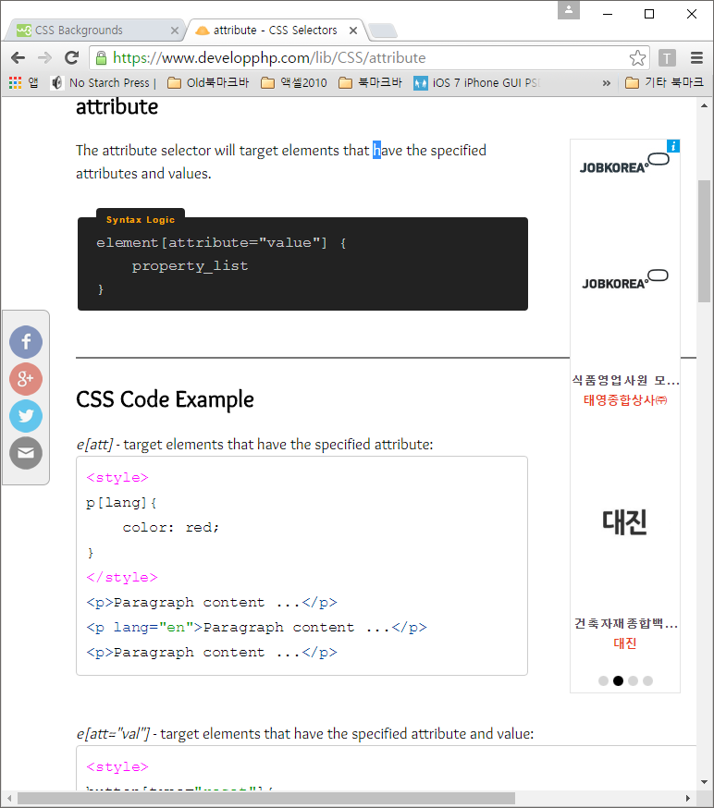

1. attribute : 속성 선택자는 특별하게 지정된 속성과 값을 가진 타켓 엘리먼트이다. [ attribute=”value”] 사용

|  |  |
| --- | --- |
| e[att="val"] –타켓엘리먼트는 특별속성과 값을 갖는다.  <style>  button[type="reset"]{  background: darkred;  color: white;  }  </style>  </head>  <body>  <button type="button">Button 1</button>  <button type="reset">Button 2</button>  <button type="submit">Button 3</button> | e[att*="val"] 특별한 문자열을 포함  contains certain value somewhere  <style>  h2[title*="econ"] {  color: orange;  }  </style>  </head>  <body>  <h2 title="first heading">Heading 1</h2>  <h2 title="second heading">Heading 2</h2>  <h2 title="third heading">Heading 3</h2>  <body> |
| e[att~="val"] – 속성의 값들은 공백으로 구분되어진다. (아래예제에서 theshow (x))  Attribute is within space separated list  <style>  input[value~="the"] {  background: pink;  }  </style>  </head>  <body>  <input value="welcome to the show">  <input value="welcome to a show">  <body> | e[att^="val"] 타켓엘리먼트는 특별속성과 값을 갖고 시작한다.  **begins** with certain value  <style>  a[href^="http"] {  color: magenta;  }  </style>  </head>  <body>  <a href="http://www.youtube.com">Watch Videos</a> <br>  <a href="contact.html">Contact Us</a> <br>  <a href="http://www.yahoo.com">Search the web</a>  <body> |
| e[att$="val"] 타켓엘리먼트가 특별한 값을 갖고 **끝난다**.  **Ends** with certain value  <style>  a[href$="gov"] {  color: red;  }  </style>  </head>  <body>  <a href="www.usa.com">Link 1</a> <br>  <a href="www.usa.gov">Link 2</a> <br>  <a href="www.usa.org">Link 3</a>  <body> | e[att|="val"]  <style>  p[lang|="en"] {  color: blue;  }  </style>  </head>  <body>  <p lang="fr-CA">Paragraph content ...</p>  <p lang="en-US">Paragraph content ...</p>  <body> |
| e[att |="val"] This will select if the start of a dash-separated list of attribute values matches the selector.  <style type="text/css">  h1[rel|="friend"] { color: red; }  </style>  <body>  <h1 rel="friend-external-sandwich">Attribute Dash Separated</h1>  <h2 rel="friend-external-sandwich">Attribute Dash Separated</h2>  <h1 rel="external-sandwich">Attribute Dash Separated</h1>  </body> |  |

1. descendant

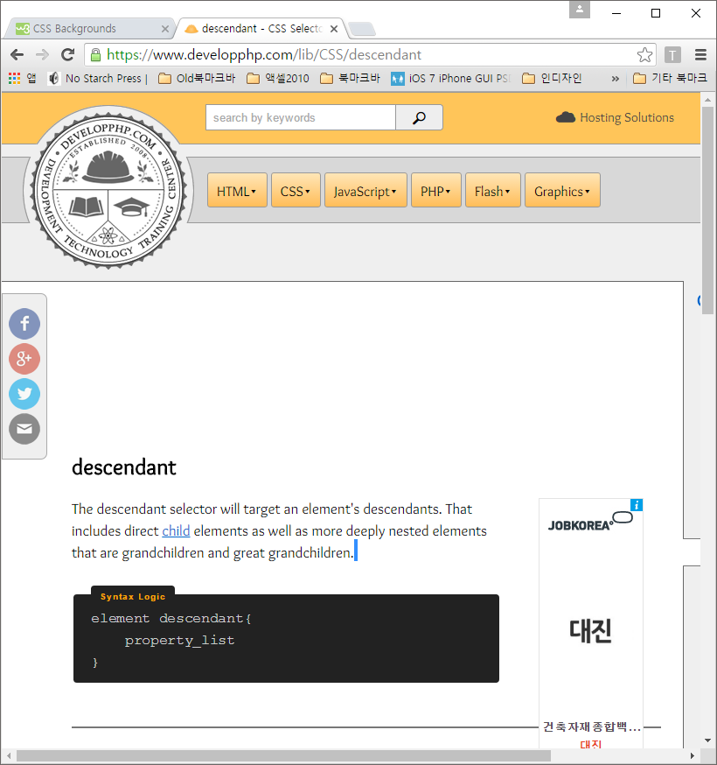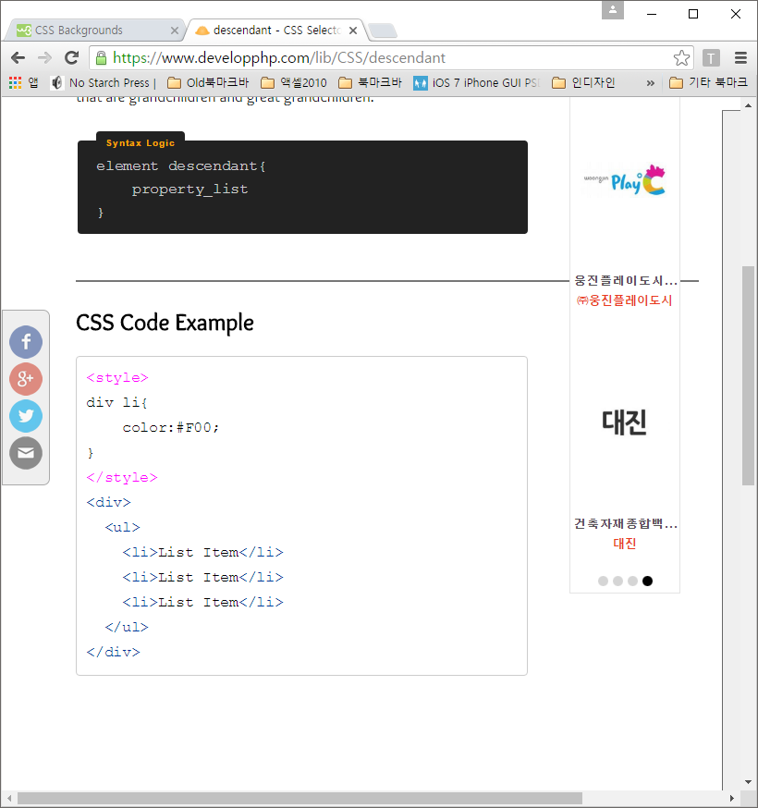

1. child

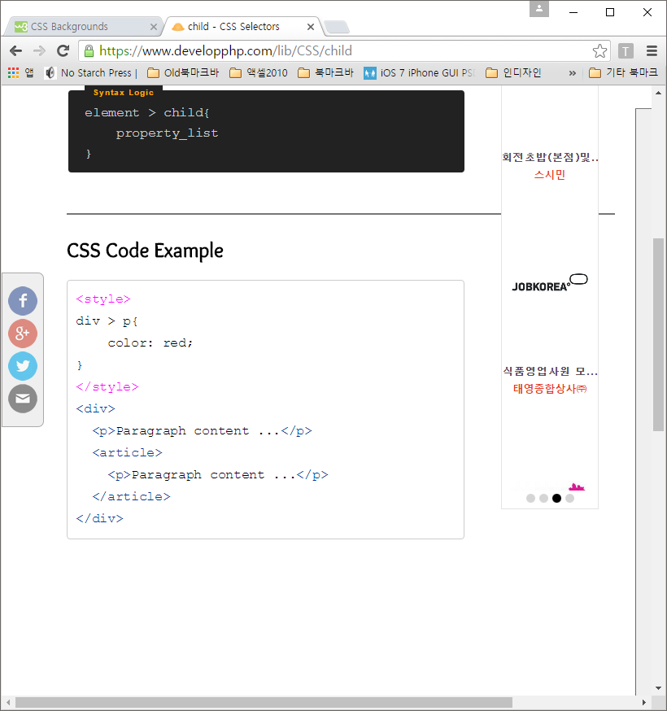 

|  |  |  |
| --- | --- | --- |
| **8. adjacent sibling (인접한 것들끼리)**  문법 :  sibling **+** sibling { property_list  } | h3 + p {  font-family:"Comic Sans MS", cursive;  text-decoration:underline;  }  </style>  </head>  <body>  <h3>Some Stuff</h3>  <p>Stuff inside my paragraph...</p>  <p>Stuff inside my paragraph...</p>  <p>Stuff inside my paragraph...</p>  <h3>More Stuff</h3>  <p>Stuff inside my paragraph...</p>  <p>Stuff inside my paragraph...</p>  <p>Stuff inside my paragraph...</p>  <body> | |
| **9 general sibling ( 동위, 형제 선택)**  문법 :  Sibling ~ sibling { property_list  } | <style>  h3 ~ p {  font-style:italic;  color:#09F;  }  </style>  </head>  <body>  <h2>Some Stuff</h2>  <p>Stuff inside my paragraph...</p>  <p>Stuff inside my paragraph...</p>  <h3>More Stuff</h3>  <p>Stuff inside my paragraph...</p>  <p>Stuff inside my paragraph...</p>  <div>Stuff inside my div...</div>  <p>Stuff inside my paragraph...</p>  <body> | |
| **10. first child**  문법 :  element:first-child { property_list  } | <style>  p:first-child {  color: skyblue;  }  </style>  </head>  <body>  <article>  <p>Paragraph content...</p>  <p>Paragraph content...</p>  <p>Paragraph content...</p>  </article>  <article>  <p>Paragraph content...</p>  <p>Paragraph content...</p>  <p>Paragraph content...</p>  </article>  <body> | |
| **11. last child**  문법 :  element:last-child { property_list  } | <style>  a:last-child {  font-family:"Arial Black", Gadget, sans-serif;  }  </style>  </head>  <body>  <a href="#">Link 1</a> <br>  <a href="#">Link 2</a> <br>  <a href="#">Link 3</a> <br>  <a href="#">Link 4</a>  <body> | |
| **12. only child**  문법:  element:only-child { property_list  } | <style>  button:only-child {  background: darkred;  color: white;  padding: 10px;  border-radius: 4px;  cursor: pointer;  }  </style>  </head>  <body>  <div>  <button>Button 1</button>  <button>Button 2</button>  <button>Button 3</button>  <button>Button 4</button>  </div>  <div>  <button>Button 5</button>  </div>  <body> | |
| **13. nth child**  **문법**  element:nth-child( integer |  divisible_by ) {  color:#F00; } | <style>  li:nth-child(2) {  color:#F00;  }  </style>  </head>  <body>  <ul>  <li>list item content...</li>  <li>list item content...</li>  <li>list item content...</li>  </ul>  <body> | |
| <style>  li:nth-child(even) {  color: red;  }  li:nth-child(odd) {  color: blue;  }  </style>  </head>  <body>  <ul>  <li>list item content...</li>  <li>list item content...</li>  <li>list item content...</li>  <li>list item content...</li>  <li>list item content...</li>  <li>list item content...</li>  </ul>  <body> | <style>  li:nth-child(2n+0) {  color: red;  }  li:nth-child(2n+1) {  color: blue;  }  </style>  </head>  <body>  <ul>  <li>list item content...</li>  <li>list item content...</li>  <li>list item content...</li>  <li>list item content...</li>  <li>list item content...</li>  <li>list item content...</li>  </ul>  <body> |
| **14. nth last child**  **문법:**  element:nth-last-child(  integer | divisible_by ) {  property_list } | <style>  li:nth-last-child(2) {  color: red;  }  </style>  </head>  <body>  <ul>  <li>list item content...</li>  <li>list item content...</li>  <li>list item content...</li>  <li>list item content...</li>  <li>list item content...</li>  <li>list item content...</li>  </ul>  <body> | <style>  li:nth-last-child(2n+0) { /* Or (even) */  color: red;  }  </style>  </head>  <body>  <ul>  <li>list item content...</li>  <li>list item content...</li>  <li>list item content...</li>  <li>list item content...</li>  <li>list item content...</li>  <li>list item content...</li>  </ul>  <body |
| **15. empth**  문법 :  element:empty { property_list } | <style>  li:empty {  background: lightgrey;  }  </style>  </head>  <body>  <ul>  <li>List item</li>  <li></li>  <li> </li>  <li>List item</li>  </ul>  <body> | |
| **16. first letter**  **문법 :**  element::first-letter { property_list }  <p> < article >  <section> etc. | <style>  p::first-letter {  font-size: 24px;  color: #09C;  }  </style>  </head>  <body>  <p>Once upon a time on a website...</p>  <p>Later that same afternoon a great big...</p>  <body> | |
| **17. before**  **문법 :**  element::before { content:  generated_content ; } | <style>  p::before {  content: "String ... ";  }  </style>  </head>  <body>  <p>paragraph content</p>  <p>paragraph content</p>  <p>paragraph content</p>  <p>paragraph content</p>  <section> Later that same afternoon a great big...</section>  <body> | |
| **17. after**  **문법 :**  element::after { content:  generated_content ; } | <style>  p::after {  content: " ... String"; }  </style>  </head>  <body>  <p>paragraph content</p>  <p>paragraph content</p>  <p>paragraph content</p>  <p>paragraph content</p>  <section> Later that same afternoon a great big...</section>  <body> | |
| **18. link, visited, hover, active**  **문법 :**  a:link { property_list }  a:visited { property_list }  element:hover { property_list }  element:active { property_list } | <style>  a:link {  color: blue;  }  a:visited {  color: grey;  }  .myList li {  background:#CEE7FF;  padding:12px;  margin:4px;  color:#06F;  }  .myList li:hover {  background:#B7FFC4;  padding:12px;  margin:4px;  color:#090;  }  .class1:active {  font-size:50px;  }  </style>  </head>  <body>  <ul>  <li><a href="lib/HTML">HTML Library</a></li>  <li><a href="lib/CSS">CSS Library</a></li>  <li><a href="lib/JavaScript">JavaScript Library</a></li>  </ul>  <ul class="myList">  <li>List Item 1</li>  <li>List Item 1</li>  <li>List Item 1</li>  </ul>  <p class="class1">My paragraph content.. ( 액티브위해 마우스로 클릭).</p>  <p>My paragraph content...</p>  <body> | |
| **19. focus**  **문법 :**  element:focus { property_list } | <style>  input:focus {  background:#C4E1FF;  }  </style>  </head>  <body>  <input name="email">  <input name="password">  </body> | |
| <style>  #email_status {  display: none;  }  #email:focus ~ #email_status {  display: inline;  }  </style>  </head>  <body>  <input id="email" name="email" placeholder="Email Address">  <span id="email_status">Do not enter fake email address</span>  </body> | |
| **20. target**  **문법 :**  element:target { property_list } | <style>  p:target {  color:#F00;  }  </style>  </head>  <body>  <a href="#s1">Section 1</a> &bull;  <a href="#s2">Section 2</a> &bull;  <a href="#s3">Section 3</a> &bull;  <a href="#s4">Section 4</a>  <p name="s1" id="s1">Document section 1...</p>  <p name="s2" id="s2">Document section 2...</p>  <p name="s3" id="s3">Document section 3...</p>  <p name="s4" id="s4">Document section 4...</p>  </body> | |
| **21. enable**  **문법 :**  element:enabled { property_list } | <style>  input:enabled {  background-color: #DEF;  border:#80BFFF 1px solid;  }  </style>  </head>  <body>  <p><input type="text" name="firstname"></p>  <p><input type="text" name="lastname" disabled></p>  <p><input type="text" name="email"></p>  </body> | |
| **22. disable**  **문법 :**  element:disabled { property_list } | <style>  input:disabled {  opacity: 0.5;  }  </style>  </head>  <body>  <p><input type="radio" name="rg1"></p>  <p><input type="radio" name="rg1" disabled></p>  <p><input type="radio" name="rg1"></p>  </body> | |
| **23. checked**  **문법 :**  element:checked { property_list } | <style>  input:checked {  cursor:crosshair;  }  </style>  </head>  <body>  <input type="checkbox" name="cb1">  <input type="checkbox" name="cb2" checked="checked">  </body> | |
| **24. lang**  **문법 :**  element:lang(  language_code ) { property_list } | <style>  *:lang(kr) {  color:#090;  font-style:italic;  }  </style>  </head>  <body>  <p>My paragraph content ...</p>  <p lang="kr">Mi punto contenido ...</p>  <p>My paragraph content ...</p>  <p lang="kr">Mi punto contenido ...</p>  </body> | |

|  |
| --- |
| 선택자 연습문제  <!DOCTYPE html>  <html>  <head>  <style type="text/css">  img[alt~="person"][src*="placehold"] { /* selects images with alt text that contains the word "person" as the only term or in a space separated list, and a src attribute that contains the word "placehold" anywhere */  outline: 5px solid #E18728;  outline-offset: 2px;  }  [style] { /* select any element with a style attribute and outline it in red */  outline: 2px solid red;  }  body {  font-family: sans-serif;  width: 90%;  margin: 0 auto;  line-height: 1.5;  }  img { margin-right: .5em; }  hr { margin: 1em 0; }  </style>  <title></title>  </head>  <body>  <h2>Combined Attribute Selectors</h2>http://codepen.io/accounts/signup  <p>Here we select the image that has both of these attributes: alt text that contains the word "person" as either the only term or a whole word in a space-separated list, <em>and</em> a src attribute that contains the term "placehold" anywhere.</p>  <p>Note that the image with the alt text "fashion <em>personality</em>" is not selected, and the image with the alt text "famous <em>person</em> Arthur Miller" is not selected because its src attribute does not include "lorem".</p>  <div class="gallery">  <img src="http://placehold.it/150x184/" alt="fashion personality">  <img src="http://placehold.it/150x184/" alt="famous person Arthur Miller">  <img src="http://placehold.it/150/184/" alt="sports person">  </div>  <hr>  <h2>Selecting by Attribute Only</h2>  <p>This example is helpful for debugging CSS &mdash; it will select everything with an inline style attribute and outline it in red.</p>  <div>  <img style="width: 100px;" src="http://placehold.it/300/300" alt="">  <img src="http://placehold.it/100/100/cats" alt="cat">  <p style="font-size: 1.5em; width: 300px;">There's an inline style on this paragraph.</p>  <p>There is no inline style on this paragraph.</p>  </div>  </body>  </html> |

위의 예제를 자바스크립와 제이쿼리에서 사용시

|  |
| --- |
| **Css** :  .selected {  outline: 5px solid #E18728;  outline-offset: 2px;  }  img[data-availability^="out"] + figcaption:after { /* if an image's data-availability starts with "out", add an "out of stock" message after its caption. See the JS tab for how the image was replaced. */  font-style: italic;  content: ' - out of stock';  color: red;  }  /* styling for Pen, not related to attribute selectors */  body {  font-family: sans-serif;  width: 90%;  margin: 0 auto;  line-height: 1.5;  }  figure {  margin: 1em .5em;  float: left;  text-align: center;  }  .gallery img:not(:last-child) { margin-right: 1em; }  hr { clear: both; }  **자바스크립트** :  /* Just JavaScript */  var nose = document.querySelector('img[alt*="rulers"]');  nose.classList.add('selected');  /* jQuery */  $( document ).ready(function() {  /* replacing original product image with "Out of Stock" image */  $('img[data-availability^="out"]').attr({  'src' : '//s3-us-west-2.amazonaws.com/s.cdpn.io/652/out-of-stock.png',  'alt' : 'out of stock'  });  });  **Html :**  <h2>Attribute Selection with JavaScript</h2>  <p>Here we use document.querySelectorAll to select the image with an alt attribute that contains "rulers", adding the class "selected" via the .classList method. </p>  <div class="gallery">  <img src="//s3-us-west-2.amazonaws.com/s.cdpn.io/652/rulers.jpg" alt="old-fashioned rulers">  <img src="//s3-us-west-2.amazonaws.com/s.cdpn.io/652/cameras.jpg" alt="manual cameras">  <img src="//s3-us-west-2.amazonaws.com/s.cdpn.io/652/booklets.jpg" alt="rad typography booklets">  </div>  <hr>  <h2>Attribute Selection with jQuery</h2>  <p>Here we select the image with a data attribute that starts with "out". The original image is replaced by an alternate image with jQuery, and the caption gets a little extra text as :after content with CSS. </p>  <figure>  <img src="//s3-us-west-2.amazonaws.com/s.cdpn.io/652/rulers.jpg" alt="old-fashioned rulers" data-availability="in-stock">  <figcaption>Old-Fashioned Rulers</figcaption>  </figure>  <figure>  <img src="//s3-us-west-2.amazonaws.com/s.cdpn.io/652/cameras.jpg" alt="manual cameras" data-availability="in-stock">  <figcaption>Manual Cameras</figcaption>  </figure>  <figure>  <img src="//s3-us-west-2.amazonaws.com/s.cdpn.io/652/booklets.jpg" alt="rad typography booklets" data-availability="out-of-stock">  <figcaption>Type Booklets</figcaption>  </figure> |

CSS Backgrounds

* background-color
* background-image
* background-repeat (background-repeat: repeat-x; | background-repeat: repeat-y; | background-repeat: no-repeat;)
* background-attachment (background-attachment: fixed; 🡪스크롤 되지 않는다)
* background-position (background-position: right top; )

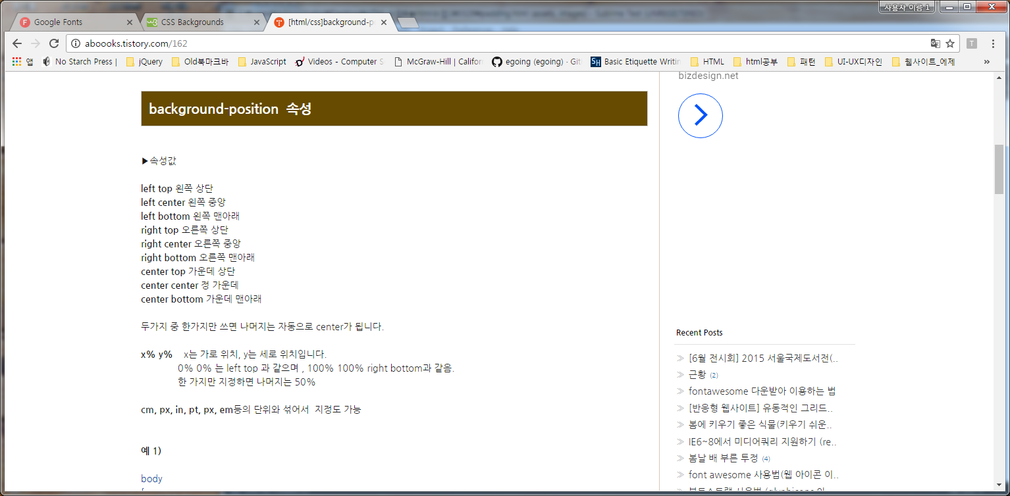

아래 참조 : https://css-tricks.com/almanac/selectors/b/blank/

### **: vs ::**

Every browser that supports the double colon (::) CSS3 syntax also supports just the (:) syntax, but IE 8 only supports the single-colon. :: is the newer format.

|  |
| --- |
| Css :  div::after {  content: "Hello";  }  Html :  <div>  <!-- Rest of stuff inside the div -->  hi  </div> |

### ::first-line

The ::first-line pseudo-element is for applying styles to the first line of an element. ::first-line allows you to style that first line of text. This pseudo-element only works on block-level elements (when display is set to either block, inline-block, table-caption, table-cell). If set on an inline element, nothing happens.

|  |
| --- |
| <!DOCTYPE html>  <html>  <head>  <title></title>  <style type="text/css">  article { padding: 20px;}  p { color: #444;}  p:first-line { color: deepskyblue;}  .p2 { color: #444;}  .p2:first-line { color: tomato;}  #p3 { color: #444;}  #p3:first-line { color: firebrick;}  #p4 { color: #444 !important;}  #p4:first-line { color: hotpink;}  </style>  </head>  <body>  <article>  <h2>::first-line vs. tag selector</h2>  <p>This paragraph color is set to <code>#444</code> with <code>p { color: #444; }</code>. Pellentesque habitant morbi tristique senectus et netus et malesuada fames ac turpis egestas. Vestibulum tortor quam, feugiat vitae, ultricies eget, tempor sit amet, ante. Donec eu libero sit amet quam egestas semper. Aenean ultricies mi vitae est. Mauris placerat eleifend leo.</p>  <h2>::first-line vs class selector</h2>  <p class="p2">This paragraph color is set to <code>#444</code> with <code>.p2 { color: #444; }</code>. Pellentesque habitant morbi tristique senectus et netus et malesuada fames ac turpis egestas. Vestibulum tortor quam, feugiat vitae, ultricies eget, tempor sit amet, ante. Donec eu libero sit amet quam egestas semper. Aenean ultricies mi vitae est. Mauris placerat eleifend leo.</p>  <h2>::first-line vs ID selector</h2>  <p id="p3">This paragraph color is set to <code>#444</code> with <code>#p3 { color: #444; }</code>. Pellentesque habitant morbi tristique senectus et netus et malesuada fames ac turpis egestas. Vestibulum tortor quam, feugiat vitae, ultricies eget, tempor sit amet, ante. Donec eu libero sit amet quam egestas semper. Aenean ultricies mi vitae est. Mauris placerat eleifend leo.</p>  <h2>::first-line vs !important</h2>  <p id="p4">This paragraph color is set to <code>#444</code> with <code>#p4 { color: #444 !important; }</code>. Pellentesque habitant morbi tristique senectus et netus et malesuada fames ac turpis egestas. Vestibulum tortor quam, feugiat vitae, ultricies eget, tempor sit amet, ante. Donec eu libero sit amet quam egestas semper. Aenean ultricies mi vitae est. Mauris placerat eleifend leo.</p>  </article>  </body>  </html> |

**::first-letter**

::first-letter is a pseudo element which allows you to style the first letter in an element, without needing to stick a <span> tag around that first letter in your HTML.

|  |
| --- |
| <!DOCTYPE html>  <html>  <head>  <title></title>  <style type="text/css">  p::first-letter {  font-weight: bold;  color: red;  }  </style>  </head>  <body>  <p>  The first letter is bold and red  </p>  </body>  </html> |

**+**

The plus sign (+) is the adjacent sibling combinator, between two paragraph tag (element) selectors. What this means is "select any paragraph tag that is directly after another paragraph tag (with nothing in between)".

|  |
| --- |
| <!DOCTYPE html>  <html>  <head>  <title></title>  <style type="text/css">  p + p {  color: tomato;  }  </style>  </head>  <body>  <div>  <p>I'm a paragraph</p>  <p>I get selected!</p>  </div>  <div>  <p>I'm a paragraph</p>  <h2>Monkey hair</h2>  <p>I will NOT get selected</p>  </div>  </body>  </html> |

**:active**

The :active pseudo selector changes the appearance of a link while it is being activated (being clicked on or otherwise activated). It's usually only seen for a split second, and provides visual feedback that the element was indeed clicked. It's most typically used on anchor links (<a href="#">).

**:blank**

The :blank pseudo-class builds upon the [:empty](http://css-tricks.com/almanac/selectors/e/empty/)pseudo-class. Like :empty, :blank will select elements that contain nothing at all, or contain only an HTML comment. But, :blank will also select elements that include whitespace, which :empty will not.

|  |
| --- |
| <!DOCTYPE html>  <html>  <head>  <title></title>  <style type="text/css">  p {  min-height: 30px;  width: 250px;  background-color: lightblue;  }  p:blank { display: none; }  p:-moz-only-whitespace { display: none; } /* Mozilla-only pseudo-class that works like :blank will */    </style>  </head>  <body>https://hired.com/join/?utm_source=syndicate&utm_medium=sponsor&utm_campaign=(b2c)(l-all)(r-swe)(q1-17-csstricks-display-unit)&utm_content=display-ad  <div class="blanks">  <p>This paragraph is not empty or blank.</p>  <p><!--this is empty and blank --></p>  <p>    <!-- this is not empty, because it has whitespace. But it is blank.-->    </p>  <p>This paragraph is not empty or blank.</p>  </div>  </body>  </html> |

**Nth-child (2n) , (2n+1)**

|  |
| --- |
| <!DOCTYPE html>  <html>  <head>  <title></title>  <style type="text/css">  ul { overflow: hidden; }  li { list-style: none; float: left; padding: 15px; }  li:nth-child(2n) { background: gray; color: pink; }  li:nth-child(2n+1) { background: black; color: #ffd800; }  li:first-child { border-radius: 10px 0 0 10px;}  li:last-child { border-radius: 0 10px 10px 0; }  </style>  </head>  <body>  <ul>  <li>menu1</li>  <li>menu2</li>  <li>menu3</li>  <li>menu4</li>  <li>menu5</li>  <li>menu6</li>  </ul>  </body>  </html> |

**:first-of-type**

Using :first-of-type is very similar to :nth-child but with one **critical difference:** it is [less specific](http://css-tricks.com/the-difference-between-nth-child-and-nth-of-type/). In the example above, if we had used p:nth-child(1), nothing would happen because the paragraph is not the first child of its parent (the <article>).

|  |
| --- |
| <!DOCTYPE html>  <html>  <head>  <title></title>  <style type="text/css">  body {  font-family: Palatino, Georgia, serif;  max-width: 32em;  padding: 1em 0 0 1em;  line-height: 1.4;  }  p:first-of-type {font-size: 1.25em;}    /*p:nth-chile(1) { font-size: 1.25em; } 이것은 아무런 변화가 없다. */  p:last-of-type { font-size: 0.75em;  font-style: italic; }  </style>  </head>  <body>  <h1>Around the World in Eighty Days</h1>  <p>"Very well, Sir Francis," replied Mr. Fogg; "if he had been caught he would have been condemned and punished, and then would have quietly returned to Europe. I don't see how this affair could have delayed his master."</p>  <p>The conversation fell again. During the night the train left the mountains behind, and passed Nassik, and the next day proceeded over the flat, well-cultivated country of the Khandeish, with its straggling villages, above which rose the minarets of the pagodas.</p>  <p>Jules Verne was a French author who pioneered the genre of science fiction in the late nineteenth and early twentieth century. Follow him on Twitter.</p>    </body>  </html> |

**:last-of-type**

The :last-of-type selector allows you to target the last occurence of an element within its container. It is defined in the [CSS Selectors Level 3 spec](http://www.w3.org/TR/selectors/) as a “structural pseudo-class”, meaning it is used

|  |
| --- |
| <!DOCTYPE html>  <html>  <head>  <title></title>  <style type="text/css">  body {  font-family: Palatino, Georgia, serif;  max-width: 32em;  padding: 1em 0 0 1em;  line-height: 1.4;  }  /*p:nth-child(2n+1) { background-color: yellow; }*/  p:first-of-type { font-size: 1.25em; color:magenta;}  p:last-of-type { font-size: 0.75em; font-style: italic;}  </style>  </head>  <body>  <h1>Around the World in Eighty Days</h1>  <span>dddd</span>  <p>"Very well, Sir Francis," replied Mr. Fogg; "if he had been caught he would have been condemned and punished, and then would have quietly returned to Europe. I don't see how this affair could have delayed his master."</p>  <p>The conversation fell again. During the night the train left the mountains behind, and passed Nassik, and the next day proceeded over the flat, well-cultivated country of the Khandeish, with its straggling villages, above which rose the minarets of the pagodas.</p>  <p>Jules Verne was a French author who pioneered the genre of science fiction in the late nineteenth and early twentieth century. Follow him on Twitter.</p  </body>  </html> |

**Nth-of-type**

|  |
| --- |
| <!DOCTYPE html>  <html>  <head>  <title></title>  <style type="text/css">  body { padding: 1em 2em;}  ul {  list-style: none;  width: 12em;  border: 1px solid #444;  padding: 0  }  li {  text-align: center;  line-height: 2;  background: slategrey;  }  div {  float: left;  margin-right: 2em;  }  pre {  font-size: 14px;  }  hr { clear: both; padding-top: 1em;  border: 0;  border-bottom: 1px solid grey;  }  .one li:nth-of-type(1) {  background: lightsteelblue;}  .two li:nth-of-type(odd) {  background: lightsteelblue;}  .three li:nth-of-type(3n+2) {  background: lightsteelblue;}  </style>  </head>  <body>  <div>  <pre>:nth-of-type(1)</pre>  <ul class="one">  <li>One</li>  <li>Two</li>  <li>Three</li>  <li>Four</li>  <li>Five</li>  <li>Six</li>  <li>Seven</li>  <li>Eight</li>  </ul>  </div>  <div>  <pre>:nth-of-type(odd)</pre>  <ul class="two">  <li>One</li>  <li>Two</li>  <li>Three</li>  <li>Four</li>  <li>Five</li>  <li>Six</li>  <li>Seven</li>  <li>Eight</li>  </ul>  </div>  <div>  <pre>:nth-of-type(3n+2)</pre>  <ul class="three">  <li>One</li>  <li>Two</li>  <li>Three</li>  <li>Four</li>  <li>Five</li>  <li>Six</li>  <li>Seven</li>  <li>Eight</li>  <li>9</li>  <li>10</li>  <li>11</li>  </ul>  </div>  </body>  </html> |

**:nth-last-of-type**

|  |
| --- |
| <!DOCTYPE html>  <html>  <head>  <title></title>  <style type="text/css">  body {  padding: 1em 2em;  }  ul {  list-style: none;  width: 12em;  border: 1px solid #444;  padding: 0  }  li {  text-align: center;  line-height: 2;  background: slategrey;  }  div {  float: left;  margin-right: 2em;  }  pre {  font-size: 14px;  }  hr {  clear: both;  padding-top: 1em;  border: 0;  border-bottom: 1px solid grey;  }  .four li:nth-last-of-type(3) {  background: lightsteelblue;  }  .five li:nth-of-type(3n+1) {  background: lightsteelblue;  }  .six li:nth-of-type(even) {  background: lightsteelblue;  }  </style>  </head>  <body>  <div>  <pre>:nth-last-of-type(3)</pre>  <ul class="four">  <li>One</li>  <li>Two</li>  <li>Three</li>  <li>Four</li>  <li>Five</li>  <li>Six  <!-- <ul>  <li>1</li>  <li>2</li>  </ul> -->  </li>  <li>Seven</li>  <li>Eight</li>  </ul>  </div>  <div>  <pre>:nth-last-of-type(3n+1)</pre>  <ul class="five">  <li>One</li>  <li>Two</li>  <li>Three</li>  <li>Four</li>  <li>Five</li>  <li>Six</li>  <li>Seven</li>  <li>Eight</li>  </ul>  </div>  <div>  <pre>:nth-last-of-type(even)</pre>  <ul class="six">  <li>One</li>  <li>Two</li>  <li>Three</li>  <li>Four</li>  <li>Five</li>  <li>Six</li>  <li>Seven</li>  <li>Eight</li>  </ul>  </div>  </body>  </html> |